C#

Chapter 1
Summary
In Chapter 1 you will learn about the history of computers, components of a computer (hardware & software) and how they represent data. Especially important in this chapter is the software development process. We will also examine the universal character set (specifically the ASCII set) that computers use to translate text into computer lingo.

These notes contain some of the highlights of this chapter. You should add any additional notes on the page(s) at the end of this packet. If you run out of space, use loose leaf paper and put them after these pages. Include anything you feel is helpful or important from your work in this chapter.

ASCII (the first 128 characters of the 65,000 Unicode characters) *American Standard Code for Information Interchange
This table below contains the first 128 characters of the Unicode character set. This group of characters is caller the ASCII character set. The unique numeric value of each is given in the “Dec” column.
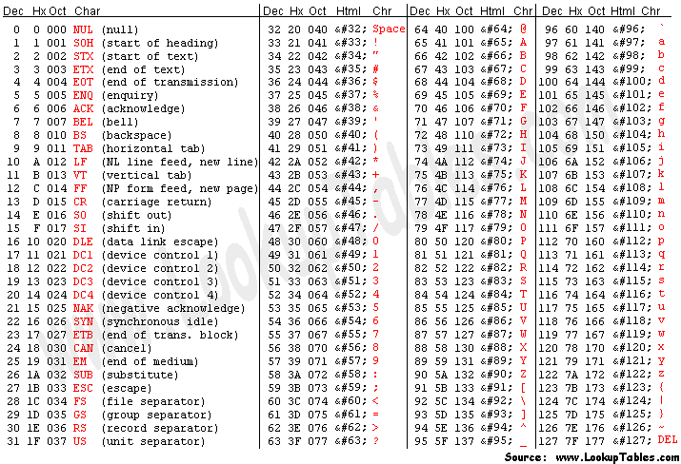

What is C# & .NET?
C# is a programming language that combines the power of the C++ language with the ease of the Visual Basic language. C# uses the “.NET” code library. This library of code elements simplifies any kind of programming you are trying to do.
Steps in the Program Development Process
When writing code it is very important that you have a plan to follow that will guide you on how to proceed. This plan is know as the Program Development Process and the steps are given here. Without this planning, or without following an organized sequence of steps, you will often waste time and your solutions might not produce accurate results.
- Analyze the Problem
  - Read the problem. Identify what they are asking you to do. What is the program supposed to accomplish? If you don’t know or if there is ANY uncertainty about what you think is being asked, ASK QUESTIONS! It is vital that you don’t waste time working on a program that does not do what is being asked. You MUST understand what the problem is asking of you. What this means in the real world is that you MUST understand what your boss is asking you to do.
- Design a Solution
  - Sketch out a solution using a flowchart. (see p. 24 of C# text for flowchart symbols)
  - Make a sketch of what the results should look like.
  - Advanced: For larger OOP use class diagrams
- Code the Solution
  - Write the program in your IDE
- Implement the Code
  - Compile
  - Resolve all syntax error shown in your error list
- Test & Debug
  - Test the program results against your expected results. If the program does what you intended it to do, then you are done. If not, debug and go back to step 3.
  - Advanced: Write a Test Plan for large projects. A Test Plan is a list of tests that need to be passed in order for the program to be verified as correct. Each test in your test plan should contain the exact steps to be performed for that test, the expected results for the test, and a area for you to enter if the test passed or failed, and if it failed how it failed.
  - A sample test plan is shown below for reference:
Steps | Expected Results | Results | Pass / Fail
Enter your student login ID and password on the computer’s login screen. | The computer logs you in. | I got an error saying invalid password | Fail

YOUR CHAPTER 1 NOTES
In this space write any important notes that you have learned from answering the chapter exercises, writing the programming exercises, from the Quick Review, or from any class discussions. (Paraphrase 18 of the 24 statements from the Quick Review on pages: 34-36)

